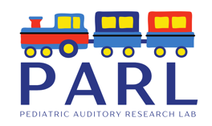

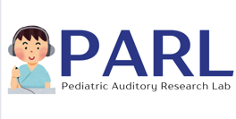


Children with Normal Hearing
wanted for a Research Study on Hearing and Language Development to help Children with Hearing Loss

- The Pediatric Auditory Research Laboratory is conducting a study on speech processing abilities in deaf and hard of hearing infants and children.
- Seeking infants and children from 1 month to 10 years.
- Your child will hear different speech sounds in quiet and with noise while brain responses are recorded.
- Your participation will help infants and children who have hearing loss.
- The testing session will last less about one hour.
- Your child must not have hearing loss.
- Families will receive $20 to compensate for their time and driving expenses.

To learn more about this research or if you are interested in participating, please contact the Pediatric Auditory Research Laboratory at the School of Communication Sciences and Disorders:
Thierry Morlet, PhD
tmorlet@memphis.edu

