2025 UoM Lambuth Student Symposium

SYMPOSIUM DATE: Friday, February 28, 2025

SUBMISSION DEADLINE: Friday, February 14, 2025

LOCATION: UM Lambuth Student Union, Hamilton Room

OVERVIEW: The Student Symposium is a forum where any undergraduate student may present their original work in a manner appropriate to their discipline. This may include creative work, experimental research, analytical papers, or another type of work appropriate to your discipline. Work will be presented in either a 15-minute oral/live session or a research poster/visual arts session. Completed work, work in progress, and proposals are welcome.

INCENTIVE: Each presenter will also receive a free tee shirt. Presentations are valued by many graduate programs. Presentation at this symposium counts as one of the three requirements for Research Scholar Designation at graduation.

. . . . . . . . . . . . . . . . . . . . . . . . . . . . . . . . . . . . . . . . . . . . . . . . . . . . . . . . . . . . . . . . . . . . . . . . . . . . . . . . . . . . . . . . . .

GENERAL GUIDELINES:

- Students may submit work as individual authors or as part of a team of student co-authors.
- Submissions will undergo a review by a panel of faculty. The panel reserves the right to reject any submissions that do not meet the guidelines.
- The title and author(s) will appear EXACTLY as they are typed in your submission. Please double check punctuation and spelling before submitting.
- Students are expected to work with a faculty mentor to ensure that the abstract and subsequent presentation is appropriately written for the academic discipline.
- If accepted, students are expected to make arrangements to be available for their presentation time on their assigned date.

POSTER/VISUAL ARTS PRESENTATION INFORMATION

- A tri-fold table-top presentation board with clips will be provided for anyone presenting in this category. If you have work that is not appropriate for this board, please email Lam_undergradresearch@live.memphis.edu to discuss presentation needs.
- Include the work’s title, author name(s), and school affiliation on your presentation.
- Use a university-approved logo on a research poster.
- Be prepared for friendly conversation and questions about your work.
- As this is a formal event, wear professional attire and use professional behavior.
- Consult your faculty advisor for guidance on assembling a poster or presenting visual art.

ORAL/LIVE SESSION PRESENTATION PRESENTATION INFORMATION

- Oral or live session presenters will have up to 15 minutes to present their work.
- Projection equipment will be provided if you choose to use it.
- A microphone will also be provided.
- Be prepared for friendly conversation and questions about your work.
- As this is a formal event, wear professional attire and use professional behavior.
- Consult your faculty advisor for guidance on this presentation.

. . . . . . . . . . . . . . . . . . . . . . . . . . . . . . . . . . . . . . . . . . . . . . . . . . . . . . . . . . . . . . . . . . . . . . . . . . . . . . . . . . . . .
SUBMISSIONS

Submit your work online at https://forms.gle/ErmGzZjGsxo3zJ9c7. Your work will include an abstract that should follow the guidelines below.
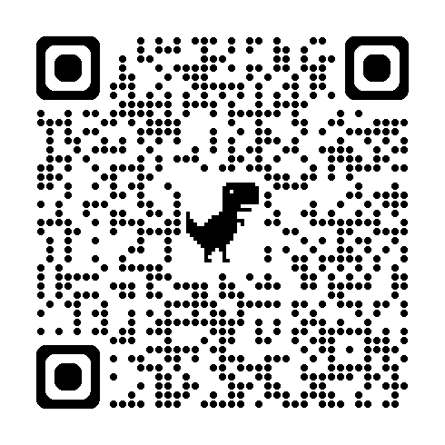

ABSTRACT GUIDELINES

Use 300 words or less to clearly state the central question and/or purpose of your work, and provide a brief description of the methodology or argument. Ensure your abstract is well-written and well-organized.

Abstract guidelines for humanities, science, social sciences, technology, mathematics, etc.:
- Clearly state the central research question and/or purpose of the project.
- Provide brief context to explain the significance of the topic and its attempt to make a unique contribution. For some disciplines, such as the sciences, this will consist of a brief background of relevant scholarly literature.
- Provide a brief description of the research methodology or topic.
- If appropriate for your field, state conclusions or expected results and the context in which they will be discussed.
- Include text only (no images or graphics)
- Be well-written and well-organized.

Abstract guidelines for performing arts:
- Clearly state the central research question and/or purpose of the project, which may include a discussion of compositional or performance aspects of the work. Why did you create this work or choose this work to perform? What aspects of music are you exploring?
- Provide brief, relevant scholarly or research context (no actual citations required) that demonstrate its attempt to make a unique contribution to the area. How does the composition and/or performance advance the development of your creative output?
- Provide a brief description of the methodology. Provide a brief description of the work from a compositional or performative standpoint.
- State conclusions or expected results and the context in which they will be discussed. How did the composition of the work or preparation for the performance affect your musical understanding and output?
- Include text only (no images or graphics). Include a link (e.g., google drive, dropbox, etc) to a recording of the work and a score of the work if a performance is being proposed.
- Be well-written and well-organized.

Abstract guidelines for visual arts:
- Clearly state the central research question and/or purpose of the project. Provide an artist statement.
- Provide brief, relevant scholarly or research context (no actual citations required) that demonstrate its attempt to make a unique contribution to the area of inquiry. In the statement, identify your influences and inspirations (e.g., other established artists), movements that are referenced or serve as inspiration, political/ cultural/ social issues that the work responds to, and/or personal events the work responds to (e.g., adventures, medical diagnosis, etc.).
- Provide a brief description of the methodology. What techniques were used? It could be as basic as oil painting on primed canvas, or a more in-depth explanation of the experimental process.
- State conclusions or expected results and the context in which they will be discussed. What did you learn? What was successful? What things could be addressed in future pieces? How does this piece fit into your portfolio or future works?
- Include text only (no images or graphics)
- Be well-written and well-organized.

